Mitten Place Value
Tens & Ones

Choose 2 mitten cards from the pile. Make the biggest number and record it on the sheet. Mark it in the tens, ones, and total column. Then using the same cards make the smallest number. Record it in the tens, ones, and total columns. Trade the cards in for 2 new cards and repeat!

Print out two sets of the cards so you can make all numbers 10 through 99!
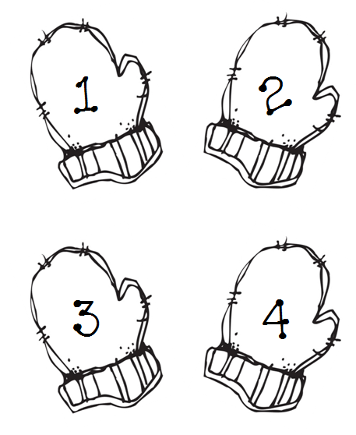

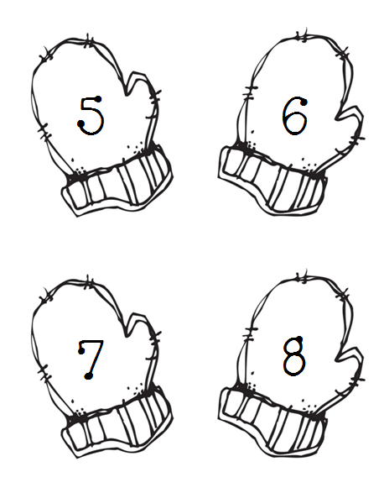

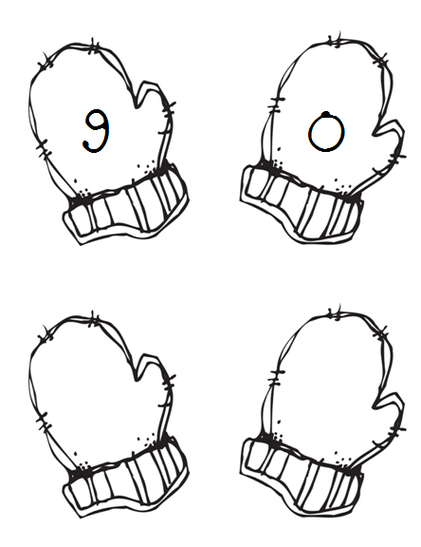

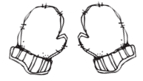
Mitten Place Value
Tens and Ones
Name: ______________
Tens | Ones | Total

