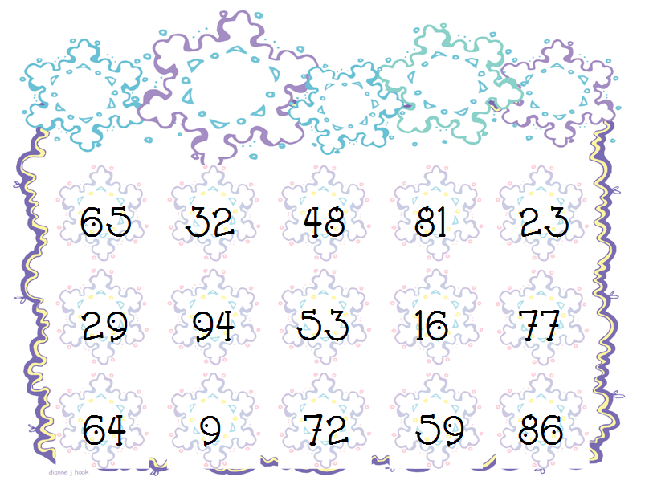
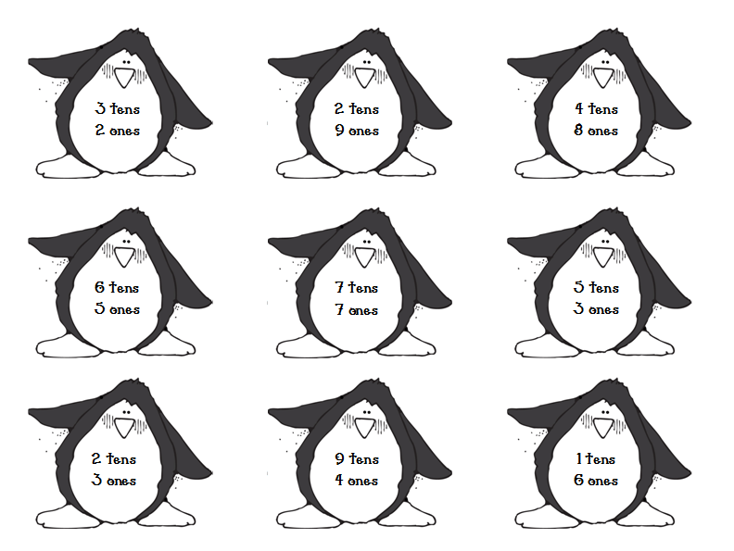
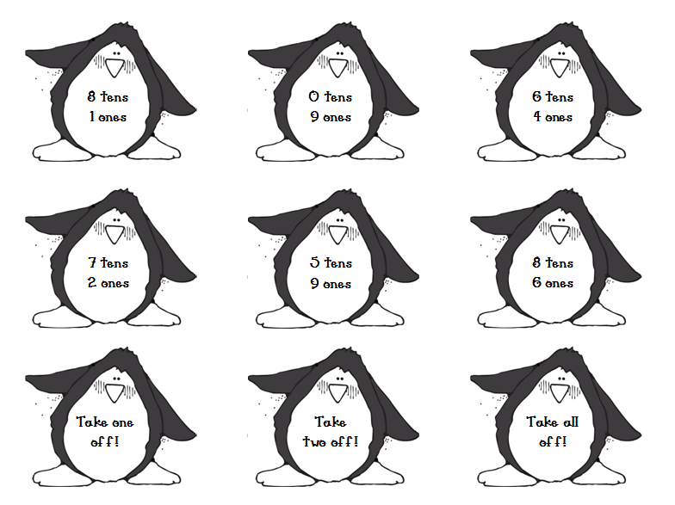
Penguin Place Value
Choose a card. Find the number on the game board and cover it. If you choose a “take 1, 2, or all off” remove game pieces and then continue play. Game is over when all the numbers are covered.

